GoInvestMe – A Crowdfunding Investment Platform for Startups

Final Year Project Proposal

Session 2015-2019

A 4th Year Student

A project submitted in partial fulfilment of the

COMSATS Single Degree Program

Of

BSc. (Hons.)BS in Software Engineering (CUI)

Department of Computer Science

COMSATS University Islamabad, Lahore Campus

11 September 2018

**Project Registration**

|  |  |  |  |  |  |  |  |
| --- | --- | --- | --- | --- | --- | --- | --- |
| Project ID (for office use) | | |  | | | | |
| Type (Nature of project) | | | [X] **D**evelopment [ X ] **R**esearch [✓ ] **R**&**D** | | | | |
| Area of specialization | | |  | | | | |
| **Project Group Members** | | | | | | | |
| Sr.# | Reg. # | Student Name | | CGPA | Email ID | Phone # | Signature |
| (1) | FA15-BSE-056 | Jahanzaib Maqsood | |  | [FA15-BSE-056@ciitlahore.edu.pk](mailto:FA15-BSE-056@ciitlahore.edu.pk) | 0334-6672438 |  |
| (2) | FA15-BSE-101 | Muhammad Usama Ashraf | |  | [FA15-BSE-101@ciitlahore.edu.pk](mailto:FA15-BSE-101@ciitlahore.edu.pk) | 0313-0732539 |  |
| (3) | FA15-BSE-054 | Imran Latif | |  | [FA15-BSE-054@ciitlahore.edu.pk](mailto:FA15-BSE-054@ciitlahore.edu.pk) | 0300-4540725 |  |
| Name & Signature of Batch Advisor  (If students are eligible for FYP) | | | | |  | | |

Plagiarism Free Certificate

1. This is to certify that, I am Jahanzaib Maqsood S/O _Maqsood Ahmed_, group leader of FYP under registration no CIIT/FA15-BSE-056/LHR at Computer Science Department, COMSATS University Islamabad, Lahore Campus. I declare that my supervisor checks my FYP proposal and the similarity index is __ % that is less than 20%, an acceptable limit by HEC. Report is attach here with as Appendix A.

Date: Name of Group Leader: __ Jahanzaib Maqsood _ Signature: _____________

Name of Supervisor: Sajid Ibrahim Hashmi Co-Supervisor (if any): ____________________

Designation: Assistant Professor Designation: _____________________

Signature: Signature: _____________________

**Approval of FYP Management Committee**

Committee Member 1: Name: _____________________

[ ] Accept [ ] *Defer [ ] *Reject Signature: _______________

*Remarks: ________________________________________________________________________

Committee Member 2: Name: _____________________

[ ] Accept [ ] *Defer [ ] *Reject Signature: _______________

*Remarks: ________________________________________________________________________

Convener: Name: _____________________

[ ] Accept [ ] *Defer [ ] *Reject Signature: _______________

*Remarks: ________________________________________________________________________

# Project Abstract

In this project, we are going to develop a platform that make a place for meeting between Investors and entrepreneurs using crowdfunding. Entrepreneurship is a way to start the business in which entrepreneur lease money from the investor. In this platform, entrepreneurs can share their ideas abstract and then deal with investor. Relationship between these people can prove to develop and influence the growth of new venture. According to people interest, profile will be show of other person. Our project based on three applications. Android and web app will provide same functionality and last one desktop application for the database control and other admin responsibilities.

Table of Contents

1 Project Abstract 3

2 Introduction 5

2.1 Entrepreneurship 5

2.2 Crowdfunding 5

2.2.1 Types of Crowdfunding 5

2.2.2 Working of Crowdfunding Platform 5

2.2.3 What is in it for Investors? 6

2.3 Entrepreneurs 6

2.3.1 Types of Entrepreneurship 6

2.4 Investor 6

2.4.1 Types of Investors 6

3 Motivation and Scope 6

4 Related Work 6

4.1 EquityNet 6

4.2 KickStarter 7

4.3 Patreon 7

4.4 PledgeMusic 7

5 Goals and Objectives 7

6 Individual Tasks 7

7 Gantt Chart 9

8 Tools and Technologies 9

8.1 ASP.net 9

8.2 Xamarin 9

8.3 Microsoft SQL Server 9

9 REFERENCES 10

# Introduction

## Entrepreneurship

From the starting of human history, people use to do business in the various way. In the 20st Century Entrepreneurship taking place.

Entrepreneurship is the technique of planning, launching and running a venture or business. The people who create these businesses are called entrepreneurs. [1]

Richard Cantillon (Irish French Economist) first study the entrepreneurship in late 17th and early 18th century. In medieval time’s guilds in Germany, a special permission is needed for a craftsman to work as an entrepreneur. [3]

## Crowdfunding

Crowdfunding is the use of small sums of money from a large number of people to fund a business venture.

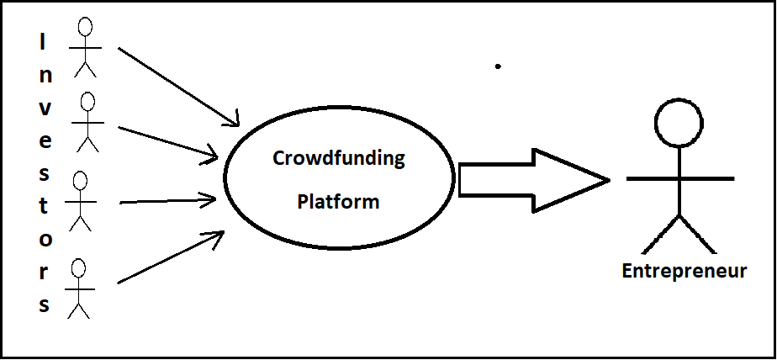

Figure 1 : Crowdfunding Platform working

### Types of Crowdfunding

* Reward based crowdfunding
* Equity based crowdfunding
* Donation based crowdfunding
* Litigation crowdfunding
* Debt based crowdfunding

### Working of Crowdfunding Platform

Entrepreneurs can raise funds from anyone with money to invest from the Crowdfunding platform. Crowdfunding provides a platform to share the ideas with the investors. [4] Shiroi Hana a restaurant in USA need $ 32,000 and raised fund of $ 429,860 which is 1,330 % of required amount via Kickstarter a reward based crowdfunding platform. These platforms generate income from a percentage of total funds raised.

### What is in it for Investors?

Mostly crowdfunding platform are reward based like Kickstarter, Patreon. They invite investors to fund the projects in exchange of gifts for their investments. Such as, the maker of a new game sends the early copies of their games to its investors.

The popularity of equity based is growing in because it allows entrepreneurs to raise funds from investors without giving up control on their venture. [4]

## Entrepreneurs

Entrepreneur is a person that start a new venture while taking risk, study the market opportunities and plan, organize, deploy the resources for the creating a new innovation or to improve present services or products. [2]

### Types of Entrepreneurship

* Small Business
* Scalable Startup
* Large Company

## Investor

Investor may be a person or an organization that invest finance in any other business with expectation of maximum profit return. They avoid from risk, if the chance of any risk then they do not invest finance in other ideas.

### Types of Investors

* Ting
* Angel Investor
* Peer to Peer Lender
* Venture Capitalist
* Personal Investor

# Motivation and Scope

* Why we choose this project. It is a big deal, because there are no platform for the new entrepreneurs to easily meet with investors, so we was involved in this problem as a entrepreneurs, so now we are going to develop this type of environment that help entrepreneurs and investor easily share their ideas and investment.
* Our project consists of only Equity based crowdfunding.
* Many institute are available that search on ideas and find investors for their ideas, but its long process but here they will easily communicate with their investors.

# Related Work

## EquityNet

* [Https://www.equitynet.com](https://www.equitynet.com)

EquityNet is a recognized crowdfunding and marketplace finance, operating since 2005.They are helping established companies and established businesses but there is no space for the new entrepreneurs.

It is an equity-based crowdfunding platform.

## KickStarter

* [Https://www.kickstarter.com](https://www.kickstarter.com)

Kickstarter help all the creators find the resources and support, they need to make their ideas a reality.

It is a reward-based crowdfunding platform.

## Patreon

* [Https://www.patreon.com](https://www.patreon.com)

Patreon lets all Creators to be funded by their fans for thir work. The fans donate the creators in return, the creator rewards them with the early access to their works like games, access special content.

It is a reward-based crowdfunding platform.

## PledgeMusic

* [Https://www.pledgemusic.com](https://www.pledgemusic.com)

PledgeMusic is for artists and their fans to bring them closer together. Only for Music Artists and their fans to support them and get rewards as early access to new albums or free passes to concerts.

It is a reward-based crowdfunding platform.

# Goals and Objectives

OurGoal is to build a System on which the two entities Entrepreneur and Investor meet and do their Investments. The Entrepreneurs and Investor sign up for their accounts and entrepreneur can float their idea, abstract ideas into the system interested investor can bid on their ideas and contact with the entrepreneur.

The system will contain

* + Website
  + Mobile App

# Individual Tasks

|  |  |  |  |
| --- | --- | --- | --- |
| TASK | Imran Latif | Usama Ashraf | Jahanzaib Maqsood |
| Requirements Gathering  ( Entrepreneurs) |  |  |  |
| Requirement Gathering  (Investor ) |  |  |  |
| Analysis of Requirements |  |  |  |
| User Account Management |  |  |  |
| Design user Interface |  |  |  |
| Design data-base |  |  |  |
| Build User –Interface |  |  |  |
| Build the Database |  |  |  |
| Define Interface Controller |  |  |  |
| Test User-Interface |  |  |  |
| Test Data-base |  |  |  |
| Monthly Report |  |  |  |
| Progress Report |  |  |  |
| Final Report |  |  |  |
| Preparation of presentation |  |  |  |

# C:\Users\Jahanzaib Jb\Desktop\chart.PNGGantt Chart

# Tools and Technologies

## ASP.net

ASP.NET are used for server side coding of a website or web application. We use ASP.NET because

* The backend code is easier to maintain the code when it comes to large websites.
* The Compiled Code of .NET compiles into Microsoft Intermediate Language(MSIL). [5]

## Xamarin

Xamarin is a Cross Platform Mobile Development, which make Android and iOS apps with a single shared .net code base.

## Microsoft SQL Server

Microsoft SQL server is a database server make by Microsoft Corporation because of

* Security.
* Reporting and Data Mining (SSRS, SSAS).
* Microsoft SQL integrates very well with Microsoft technologies. [6]

# REFERENCES

1. Brewer, Anthony (1992). “Richard Cantillon: Pioneer of Economic Theory. Routledge.”

2. William Stanley Jevons (January 1881). “Richard Cantillon and the Nationality of Political Economy.”

3. Rostam Afschar (2013). “Entry regulation and entrepreneurship: a natural experiment in German craftsmanship”.

4. Crowdfunding. Retrieved from Investopedia: https://www.investopedia.com/terms/c/crowdfunding.asp

5. Kalyan1052. (2011, June 22). “Advantages of asp.net over php.”

6. Feldman, B. (2014, October 27). “Why would a company choose to use an SQL server Over open-source databases.”

